Producer Business Plan

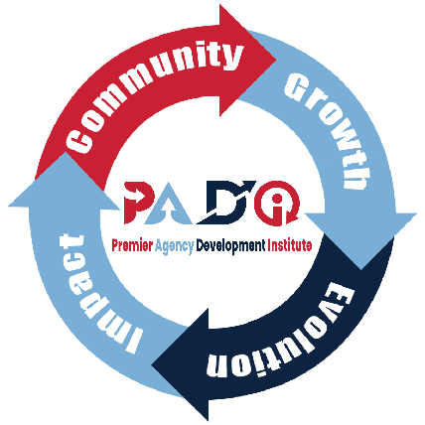



© Powered by PADI, the Premier Agency Development Institute
www.agencydevelopment.com
Producer Business Plan

Contents
1. Executive Summary 1
- Objective: 1
- Because Statement: 1
2. Annual Goal/Standard 2
- Revenue Targets and Milestones: 2
- Key Performance Indicators (KPIs): 2
3. Marketing and Branding 2
- Personal Branding Strategy: 2
- Digital Marketing Plan: 3
- Content Strategy: 3
4. Networking and Associations 3
- Key Associations: 3
- Networking Event Strategy: 4
- Community Engagement Plan: 4
5. Lead Generation and Sales Strategy 4
- Lead Source Identification: 4
- Sales Funnel Development: 5
- Quote and New Business Process: 5
6. Client Relationship Management 5
- Retention Strategies: 5
- Referral Program Development: 5
7. Operational Plan 6
- Daily and Weekly Action Plans: 6
- Time Management Techniques: 6
- Team Collaboration and Support: 6
8. Personal Development and Training 7
- Continuous Learning Plan: 7
- Mentorship and Coaching: 7
9. Implementation Timeline 7
- Plan Rollout: 7

Year:
Revenue Goal:

Executive Summary

Objective:
Define a clear, measurable goal of generating $150k+ in commission revenue. This should include a breakdown of revenue sources, such as new policies, renewals, and upselling.

Because Statement:
This personal motivational statement should reflect deep-seated reasons and convictions driving the producer. It's an articulation of their core values and how these translate into their professional life.

Annual Goal/Standard

Revenue Targets and Milestones:
Divide the annual revenue target into smaller, manageable milestones. For example, setting monthly or quarterly revenue goals, number of new policies, and average policy size.

Key Performance Indicators (KPIs):
Establish specific, quantifiable KPIs such as lead generation rate, conversion rate, client retention rate, average policy value, and time taken from lead to close.

Marketing and Branding

Personal Branding Strategy:
Develop a detailed plan to establish a strong personal brand. This includes identifying unique selling propositions (USPs), creating a consistent messaging and visual identity across all platforms, and aligning with the 'Because' philosophy.

Digital Marketing Plan:
Create a comprehensive digital marketing strategy. This should include tactics for social media engagement (such as LinkedIn and Facebook), content marketing (blogging, webinars, e-books), email marketing campaigns, and SEO for personal or agency websites.
Content Strategy:
Develop a calendar for content creation and distribution. The content should be informative, engaging, and relevant to the target audience. Include topics such as insurance tips, industry updates, personal insights, and client success stories.

Networking and Associations

Key Associations:
Identify and prioritize associations and groups that offer the best networking opportunities. Plan for active participation in these associations, including taking up roles or speaking engagements.

Networking Event Strategy:
Create a plan for attending relevant events, with specific goals for each (like number of new contacts to make, follow-up meetings to set up, etc.). Develop a follow-up strategy for contacts made at these events.

Community Engagement Plan:
Outline initiatives for community involvement, such as sponsoring local events, volunteering, or participating in community projects. This not only increases visibility but also builds trust and reputation in the community.

Lead Generation and Sales Strategy

Lead Source Identification:
Identify a mix of lead sources, including digital marketing, referrals, networking, cold calling, and partnerships with other businesses. Detail strategies for each source.

Sales Funnel Development:
Develop a detailed sales funnel that guides potential clients from awareness to decision-making. Include strategies for each stage of the funnel, like educational content for the awareness stage and personalized consultations for the decision stage.

Quote and New Business Process:
Outline a systematic approach for quote generation, follow-up, and conversion. This includes setting up efficient systems for quote delivery, regular follow-ups, and handling objections.

Client Relationship Management

Retention Strategies:
Develop comprehensive strategies for client retention, including regular check-ins, personalized policy reviews, and exclusive client events or webinars.

Referral Program Development:
Design an attractive referral program with clear incentives for clients. Outline strategies for promoting this program to existing clients and how to track and reward referrals.

Operational Plan

Daily and Weekly Action Plans:
Draft detailed daily and weekly schedules that align with broader goals. This includes dedicated time for client meetings, lead generation activities, networking, and personal development.

Time Management Techniques:
Incorporate specific time management methods, like batching similar tasks, setting dedicated hours for client interactions, and using time-tracking tools to maximize efficiency.

Team Collaboration and Support:
If working in a team, develop strategies for collaboration, role division, and mutual support. Include regular team meetings, shared goals, and collaborative tools.

Personal Development and Training

Continuous Learning Plan:
Lay out a plan for continuous learning and skill development. This could include attending industry conferences, enrolling in online courses, and participating in workshops.

Mentorship and Coaching:
Encourage engagement with mentors or coaches. Outline how to find a suitable mentor/coach and the structure of these mentorship sessions.

Implementation Timeline

Plan Rollout:
Provide a month-by-month timeline for rolling out the plan. Include key milestones, deadlines for achieving specific goals, and periods for reviewing and adjusting strategies.

