

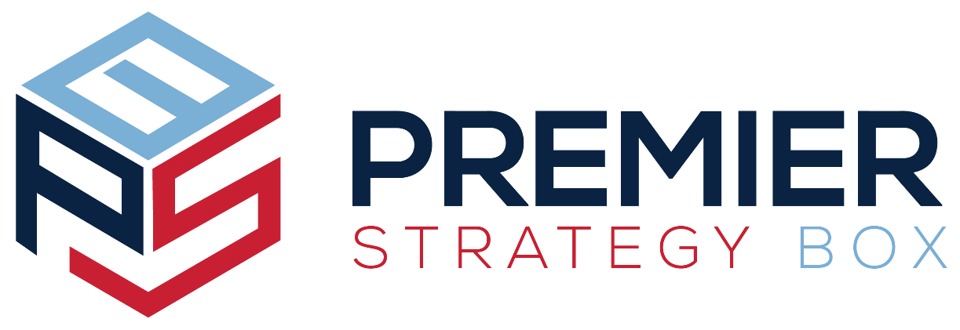

Property & Causality Consulting and Brokerage Services

Prepared for
Presented by:
Producer

© Powered by Premier Strategy Box
info@mystrategybox.com | www.mystrategybox.com

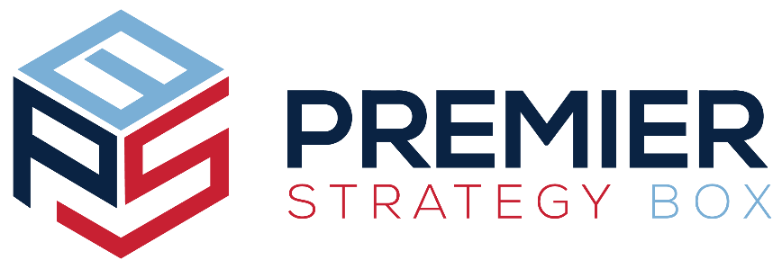

PROPERTY & CAUSALITY CONSULTING AND BROKERAGE SERVICES

Contents

1. Executive SummAry 1
Our Value Proposition 1
Situation Analysis 1
Plan Implementation 1
Communications 2
2. Property & Casualty Services 2
Risk Management 2
Exposures 2
Loss Control Techniques 2
Communications 3
Employee Safety Manuals 3
3. Premium Recap 3
How Do We Measure Up? 4
4. Non Disclosure Agreement- Proposal 5

© Powered by Premier Strategy Box
info@mystrategybox.com | www.mystrategybox.com

Executive SummAry
Your Agency Here combines years of experience with leading-edge products to provide exceptional service and value to our customers. Our product offering includes insurance products and risk management services for commercial property and casualty, and marine; specialty coverages; surety; and employee benefits, including health, life, disability, and payroll deduction personal lines programs.
Headquartered in YOUR STATE HERE, we think globally but act locally, with personal services designed specifically for each individual client. Your Agency Here shares information and resources with national networks of brokers to ensure we can meet your every need, and find answers to your questions quickly and efficiently.

Our Value Proposition
Our goal is to achieve long-term relationships focused on bringing value to your risk management and insurance programs. We commit to utilizing our collective talent to support your risk management and insurance goals.
We will deliver to you the highest quality property and casualty insurance programs and strategic planning consultation services in a manner that is most suitable to achieving your business goals.
We promise to identify activities that drive claim frequency and severity, and implement an action plan to contain losses. We will identify training needs and provide on-site assistance to actively address Your Prospect Here loss sources and promote a safe work environment for your employees.

Situation Analysis
You face many environmental challenges, including safety issues, OSHA compliance burdens, property and casualty carrier consolidation, rate fluctuations, and increased litigation activity. This challenging environment dictates a change in the way you purchase and manage your insurance programs. In order to compete in your marketplace you must adopt a total cost of risk management philosophy based on data-driven decisions and globally positioned communications.

Plan Implementation
Securing the best insurance package for your business begins with planning. Analyzing all your risks is critical to successful implementation of your property and casualty insurance programs, while conversations with employees, managers and vendors will uncover areas that need additional attention. Your Agency Here will partner with you by providing ongoing assistance, consultation and service that will help you control your insurance expenses and promote workplace safety.

Communications
Understanding the increased complexity of property and casualty insurance is a challenge. Staying abreast of the issues you face and developing strategies to meet the constant demands of business can give you a competitive edge. Your Agency Here’s communication programs will help you stay on top of the changes affecting the property and casualty insurance industry and your risk management program.

Property & Casualty Services
Our range of value-added services includes delivering you custom solutions for all of your risk management needs including: exposure analysis, loss control techniques, OSHA compliance and reporting, safety education and training, claims analysis, and developing safety policies and programs.

Risk Management
- We promise to identify your exposures to loss.
- We promise to examine and recommend alternative techniques to control your loss.
- We promise to implement and monitor the techniques we recommend.
- We promise to seek continuous improvement.
We have many tools and resources available to help you achieve your risk management goals.

Exposures
- Is your property valued correctly?
- Do you have employment-related issues?
- Do you have workers’ compensation issues you don’t know how to address?
- Is your net income protected?
- How much insurance do you need to protect your net income? Your assets?
- What deductibles should you have?
We will not take your business for granted. We promise to learn all we can about your business so we can provide you with expert recommendations and solutions to minimize exposures.

Loss Control Techniques
- How can you avoid loss?
- How can you reduce the potential for loss?
- Can you separate your losses?
- Can you transfer risk through contracts?
- Did you know that 75% of commercial insurance expenses are claims-driven?
We promise to explore the answers to these questions and many more with you. We promise to look for ways to reduce your claims-driven expenses through aggressive cost containment strategies.

Communications
Your Agency Here is committed to keeping you and your employees informed. Through our online services, we can provide you with payroll stuffers, workplace posters, ready to use employee newsletters, and safety alerts designed to help you control and avoid work-related losses.

Employee Safety Manuals
We are committed to helping you foster a safety-minded environment for your employees. Our dedicated staff of professionals will help you develop and implement safety manuals and policies to promote your safety culture to your entire workforce.

Premium Recap
Premium Recap
Property
Inland Marine
Auto
General Liability
Workers’ Compensation
Umbrella
Total

Acceptance by:
Authorized Signer:
Date of Acceptance:

How Do We Measure Up?
Service | Description | Check here if your current broker offers this service
Insurance Market Access | We provide access to essentially all insurance and administration markets.
National Affiliations | In addition to our own talented professionals and specialized value-added services, we have a wealth of resources available to us through several national affiliations.
Strategic Planning | We will develop a customized strategic plan for you that defines objectives and outlines the actions needed to fulfill those objectives. Our services ensure an organized, complete approach to fulfilling your risk management needs.
Five-Star Service | We pride ourselves on the level of knowledge and service we bring to our clients. All of our clients are assigned a team of specialists dedicated to serving their needs. Each client accesses our team through a single point of contact, making working with us seamless and easy.
Experience | We have a proven track record of dedication and commitment to excellence in our service to the business community.
Online Services | Awesome Agency provides 24/7 reporting services. Reporting claims, adding or deleting drivers and vehicles, or requesting a certificate of insurance is as easy as sending an email.
Resources | From asbestos to welding safety to workers’ comp statutes, our client portal Resource links offer your clients quick access to a wide variety of industry-related references.

Non Disclosure Agreement- Proposal
For the purposes of this Proposal, all information, strategies, plans, trade secrets, objectives and materials will be referred to as “Confidential Information”, and the Disclosing Party may share Confidential Information with the Receiving Party subject to the terms and covenants set forth below.
Receiving Party Obligations:
A. Non-Disclosure. The Receiving Party understands and agrees to not use or disclose the Proposal or Confidential Information for personal benefit or the benefit of any other person, corporation, association, Disclosing Party or entity, and shall take all steps necessary to protect Confidential Information from disclosure. The Receiving Party further agrees not to disclose the fact that the Proposal has been made available, that discussions or negotiations are taking place or have taken place, or any of the terms, conditions or other facts with respect to the transaction. Methods of disclosure include, but are not limited to, written, oral, electronic or any other form of recording.
B. Disclosure. The Receiving Party shall only disclose the Proposal and Confidential Information to persons within their organization on a need-to-know basis. Each person who becomes privy to the Confidential Information shall be bound by the provisions within this Agreement. This Agreement shall survive and continue after any expiration or termination of this Agreement and shall bind Receiving Party, its employees, agents, representatives, successors, heirs and assigns.
C. Indemnify. Receiving Party understands and acknowledges that any breach of this Agreement could result in damages, losses, costs or expenses to the Disclosing Party at a minimum of $10,000 and agrees to keep the Disclosing Party indemnified in respect to any and all claims which arise out of or in connection with a violation. Receiving Party understands and acknowledges that any use or disclosure regarding the Proposal or Confidential Information could cause the Disclosing Party irreparable harm, the amount of which may be difficult to ascertain, and therefore agrees that the Disclosing Party shall have the right to apply to a court of competent jurisdiction for specific performance or order restraining and enjoining any such further disclosure or breach and for such other relief as Disclosing Party deems appropriate, in addition to the remedies otherwise available at law or in equity.

Disclosing Party |  |  | Receiving Party
By: |  |  | By:
Name: |  |  | Name:
Title: |  |  | Title:

